EC2 Challenges Task:
1.Launch one EC2 instance using Amazon Linux 2:
Launch the instance Amazon Linux.
Using Command: ssh -I pemkey ec2-user@publicip.
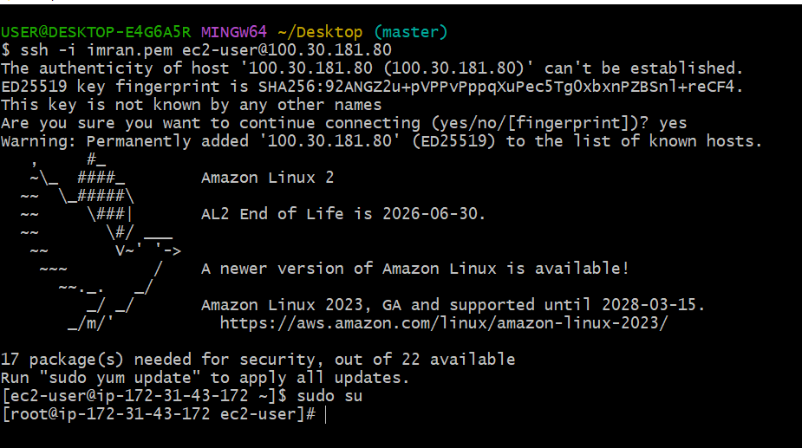
2.Install Docker:
By using the commands:
1.sudo yum update -y
2.sudo amazon-linux-extras install docker -y
3.sudo systemctl enable docker
4.sudo systemctl start docker
5.sudo usermod -aG docker ec2-user
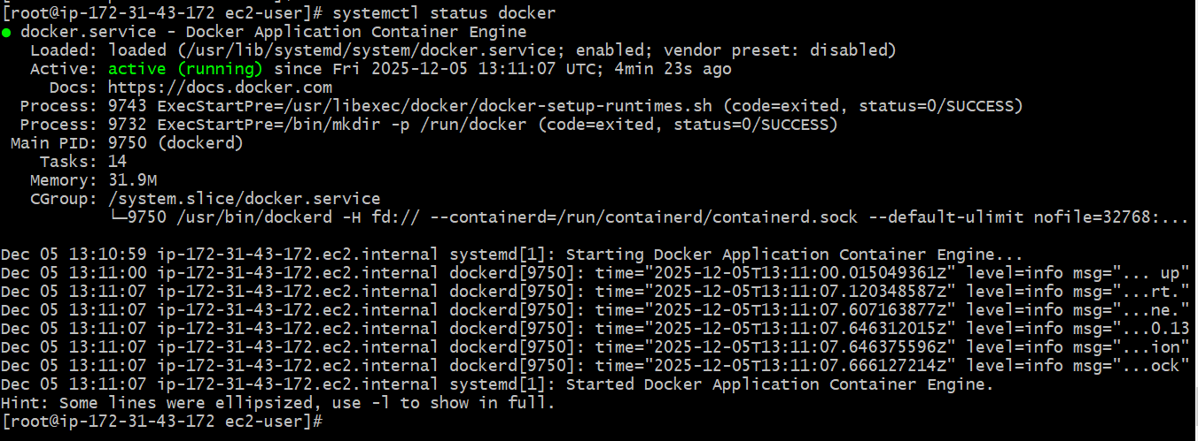
Install Jenkins:
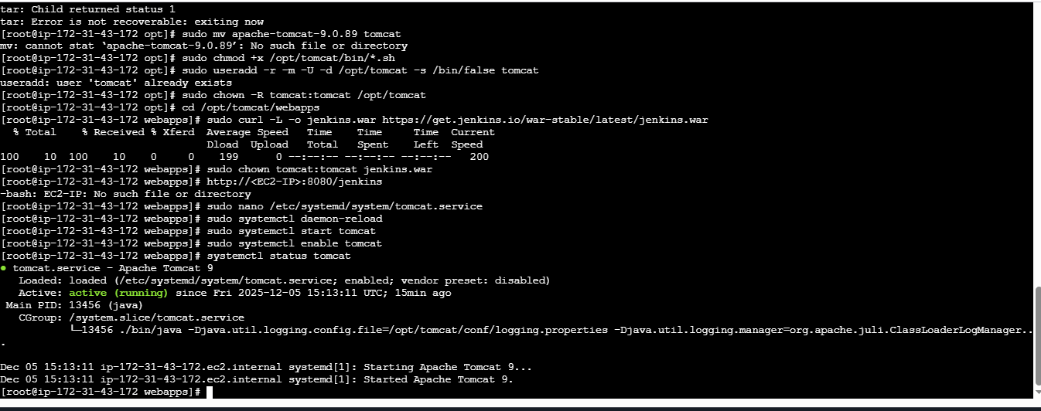
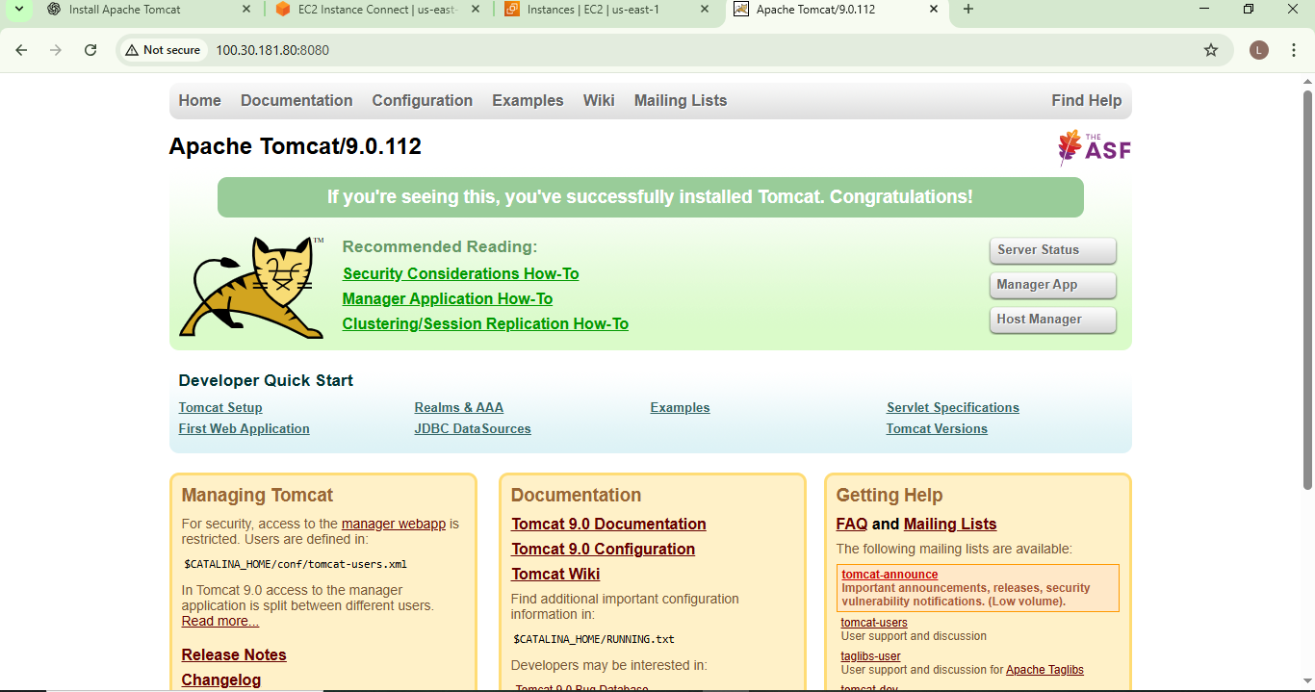
3.Install Apache:
By using the command;
sudo yum install httpd -y
sudo systemctl enable httpd
sudo systemctl start httpd
sudo systemctl status httpd
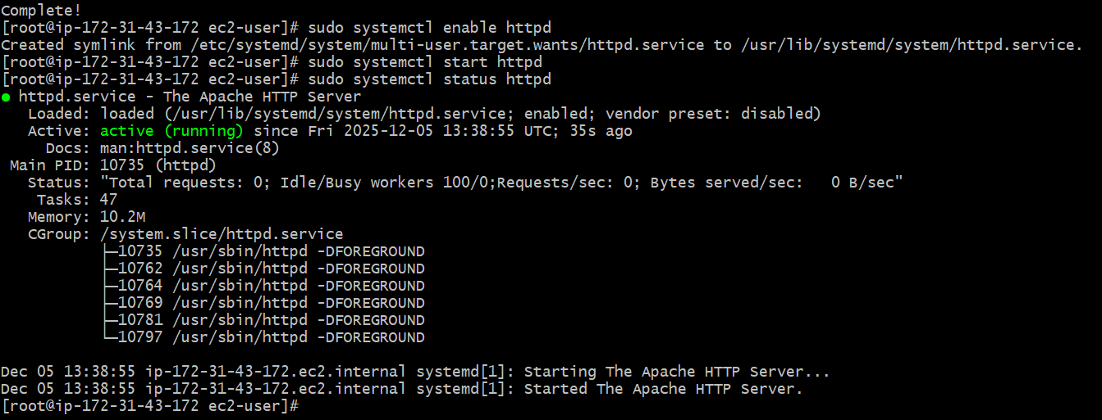
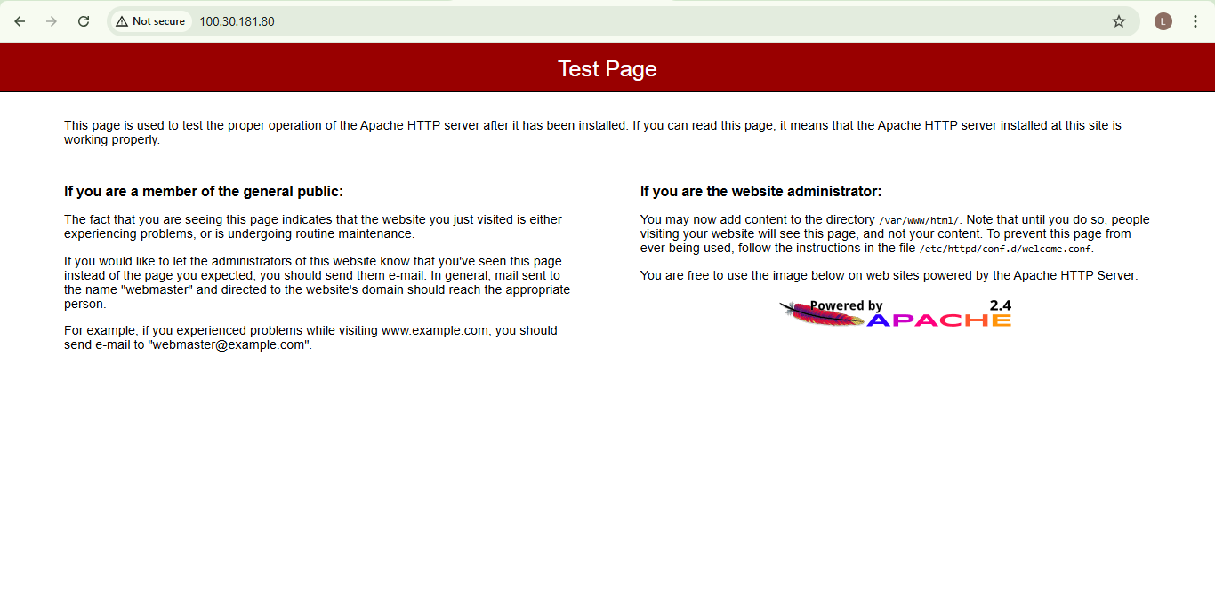

4.Install Nginx:
By using a Commands;
sudo yum update -y
sudo amazon-linux-extras install nginx1 -y
sudo systemctl stop httpd
sudo systemctl disable httpd
sudo systemctl enable nginx
sudo systemctl status nginx
active (running): O/P
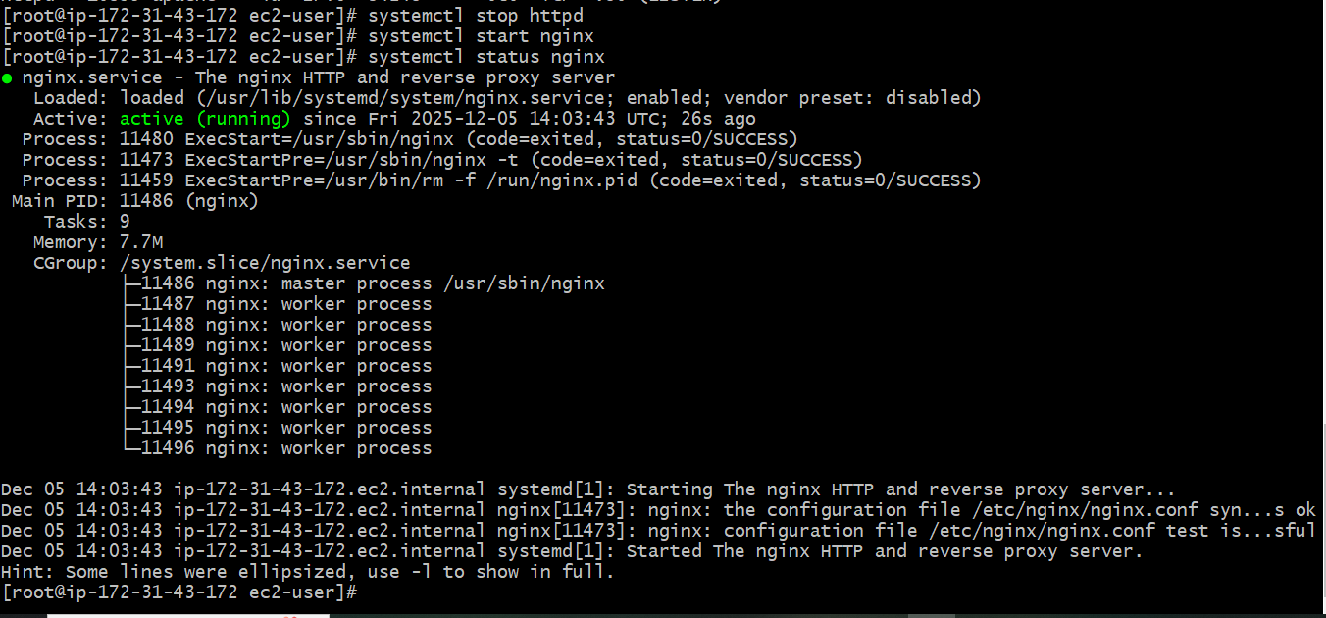
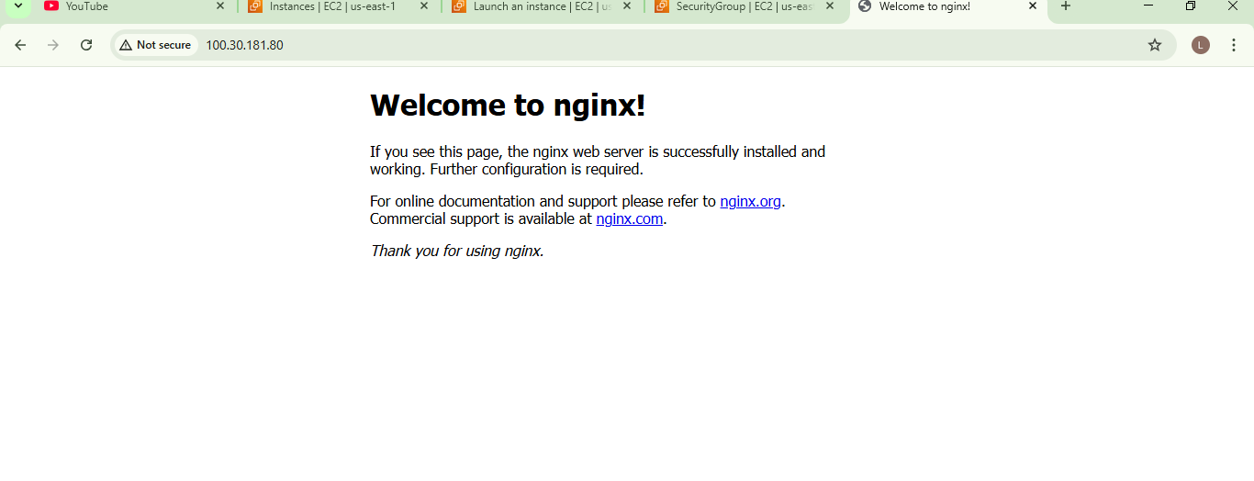

5.Install Apache Tomcat:
By using Commands;
sudo systemctl daemon-reload
sudo systemctl start tomcat
sudo systemctl enable tomcat
systemctl status tomcat
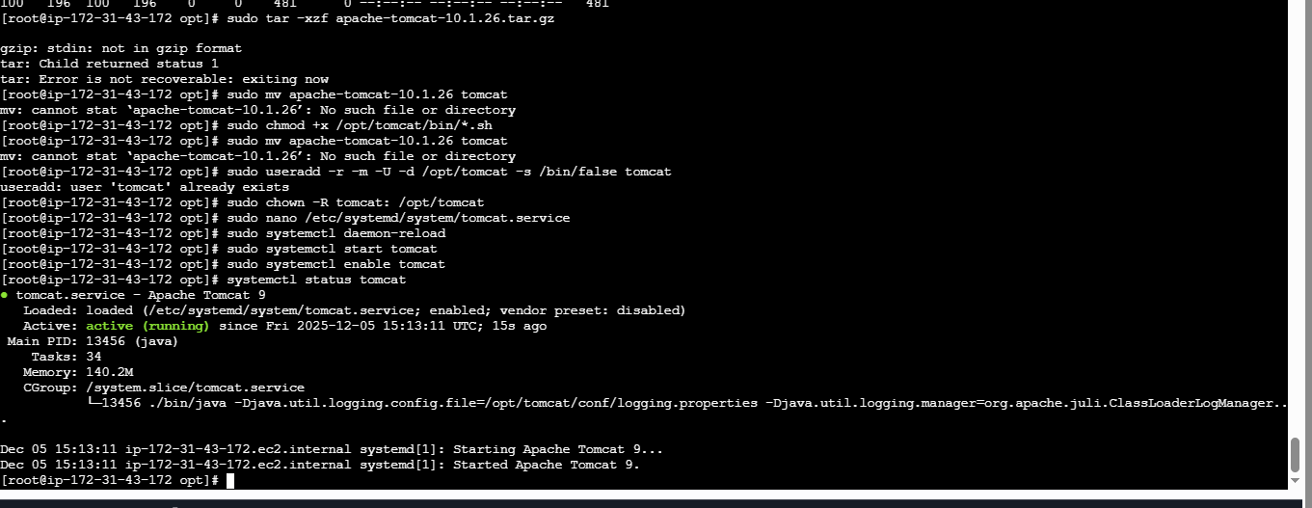

Checking Status:
systemctl status tomcat
